Household Water-Usage & Billing Monitor

1a) Data Types:

Write a Java program to store and display the following details of a household:

Number of family members – integer

Water consumed in litres – decimal value

House number – integer

Water usage status – character

Use appropriate Java data types for each value and display all the details. */

CODE :

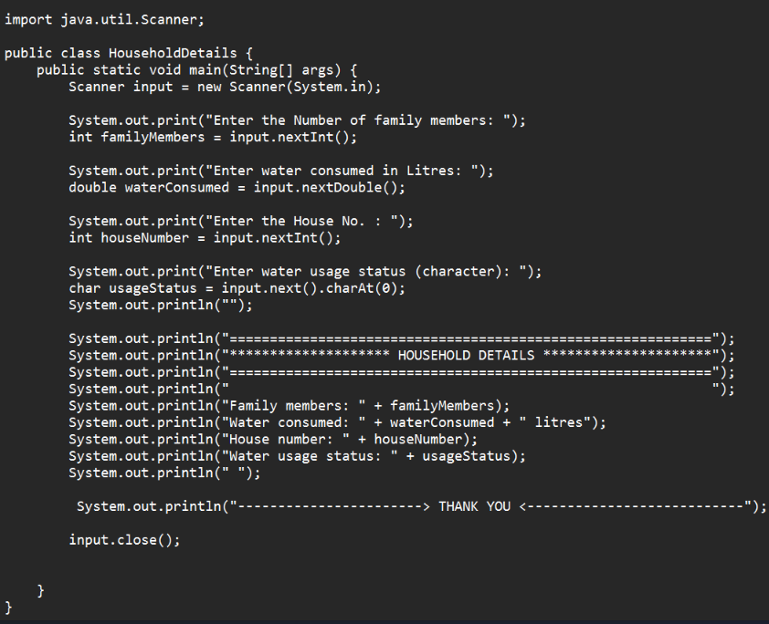

OUTPUT :

